
The 9th International Conference on Children's Health and the Environment
Saving the Children at Risk,
Shaping the Future Sustainability

From June 27-29, 2018, International Conference on Children's Health and the Environment (INCHES) is organizing its ninth conference at the Hoam Faculty House, Seoul, Korea. We cordially invite you to participate the 9th INCHES and submit abstracts for presentations.

Call for Abstract
Any theme, as long as there are health benefits for children to be gained, are welcome including the following themes:
- Environmental hazards to children (such as radiation, air pollution, pesticides, mycotoxin)
- Developmental disorders
- Health promoting settings and policies
- Consumer products: hazards and safe alternatives (such as toys, home items, gardening items)
- Information for health care providers
- Children’s health and climate change
- Indoor air pollution
- Birth cohort
Oral and Poster Abstracts must be submitted by March 1st, 2018 via e-submission for consideration by the INCHES 2018 Scientific Program Committee.

Important dates and deadlines
Abstract deadline: March 1st, 2018
Abstract acceptance notification: April 7, 2018
Early bird registration: May 15, 2018
Please visit our 9th INCHES website. Should you have any questions, please contact the 9th INCHES Organisers on inches9th@gmail.com.
Yours sincerely,

Mina Ha, MD, MPH, PhD
Yun-Chul Hong, MD, PhD
Peter van den Hazel, MD, PhD, MPH - President, INCHES

9th International Conference on Children’s Health, Environment & Safey
Seoul, Korea, June 27-29, 2018
Start | End | Day1 (6/27) |  |  | Day2 (6/28) |  |  | Day3 (6/29)
8:45 | 9:00 | Welcome and announcements / Opening ceremony |  |  | Parallel Session 7 | Parallel Session 8 |  | Parallel Session 13 | Parallel Session 14
9:00 | 10:15 | Plenary 1: Saving the children at risk, shaping the future sustainability
10:15 | 10:30 | Morning tea |  |  | Morning tea |  |  | Morning tea |  | Press
10:30 | 12:00 | Parallel Session 1 | Parallel Session 2: |  | Plenary 2: Epidemiological longitudinal studies of child health and environment – birth cohorts |  |  | Plenary 3: Children’s environmental health policy topics
12:00 | 13:00 | Lunch |  |  | Lunch |  |  | Closing Ceremony
13:00 | 14:15 | Poster session A | Poster session B |  | Poster session A | Poster session B
14:15 | 15:45 | Parallel Session 3 | Session 4: Ignite session |  | Parallel Session 9: KoCHENS | Parallel Session 10
15:45 | 16:00 | Afternoon tea |  |  | Afternoon tea
16:00 | 17:30 | Parallel Session 5 | Parallel Session 6 |  | Parallel Session 11: BiCCA | Parallel Session 12
17:30 | 18:00 | Break |  |  | Break
18:00 | 20:00 | Welcome Reception at Hoam Faculty House |  |  | Conference Dinner at Hoam Faculty House
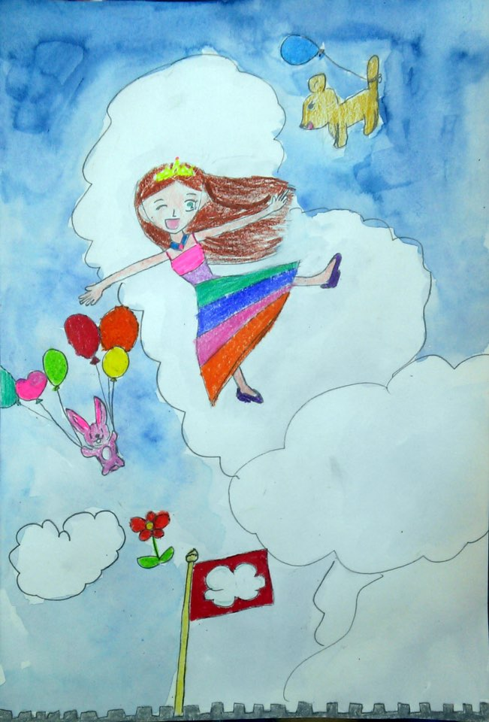
9th International Conference on Children’s Health, Environment & Safey
Seoul, Korea, June 27-29, 2018
[Over the Sky]
Surin Lee, 8 years-old

